# INTRODUCTION

The facilities for booking hotels, houses and other accommodations for customers. They operate their business in any country. Any customers need to book hotel, ins or apartment they need to visit their office which is situated in Bukit Jalil for checking the availability as well as negotiation. Recently they have decided to change their booking pattern from manual to web based system. It will help them to manage the customers booking easily and also to keep the customers data safer. It will also help staffs to keep in track their customer’s online booking request as well as easily to reply feedback to the customers. For that they hired a developer to build the web system for this reputed company. In this documentation it shows how the web-based system will be implemented and looks like (User Interface).

# PROBLEMS OF CURRENT SYSTEM

As EAZY BOOKING is having manual booking system, they are facing some problems issuing booking requests of customers. All the necessary booking stuffs are being done in hard copy. So, it become much difficult for staffs to keep the records updated all the time. As for example, if the customers need to change the check in date it become difficult for them to find out the customers booking details for updating as there are so many customers booking records. Again, regarding current system customers cannot give feedback online and also staff cannot reply to them promptly. Besides tourists from other South East Asian counties need to call directly for booking purposes. So, they cannot get the chance to view their apartment rooms or hotels rooms before they make book.

# REQUIREMENT ANALYSIS

Functional Requirements

• The system supports customers booking and able to modify them

• Customers can search based on hotel, apartment, inns (ex. Radisson, Singapore)

• When a customer search for hotels, apartment, and the search result must contain hotel or apartment information (Address, Ratings, and Price) and also its availability within choosing check in and check out date.

• Customers able to cancel their booking from their account.

• Staffs able to edit customers booking information (updating check in, check out, room preferences, bed preferences and also cancelling booking).

• Customers can book online and pay with credit or debit card.

• The system must send booking confirmation email after successful payment.

• Customers can write reviews about hotels and apartment and also rate them.

• Customers able to check their booking status from their individual account.

• Customers can send feedback or call the company for booking purposes.

• Customers can check for latest promotion or deal.

Non-Functional Requirements.

• The system must ensure that all the transferable data as for examples customers credit or debit card number, CVV Code, e-payment should be done in secured connection.

• The system must be able to handle multiple transactions a time.

• The system must provide customers 24*7 hours online booking service.

• The system should support almost all the browsers (Internet Explorer, Safari, Chrome, and Firefox). • The system should be able to convert the price from Malaysian to USD and SGD.

• System should send the newsletter about ongoing promotions or deal to registered customers.

• Customers need to cancel the booking before 24 hrs. otherwise their credit card will be charged for one day.

• In promotion time the system will charge credit card promptly.

# UML DESIGN UML design

is the shortest form of “Unified Modelling Language”. The purpose of this modelling language is to visualize the design of the system. There is total 6 types of UML diagram. They are:

♣ Class Diagram.

♣ Sequence Diagram.

♣ Use Case Diagram.

♣ Activity Diagram.

♣ System Architecture Diagram.

♣ System diagrams/wire frames.

Here we will show only 2 diagrams out of 6. For that we have chosen “Use Case Diagram” & “Class Diagram”.

## Use Case Diagram

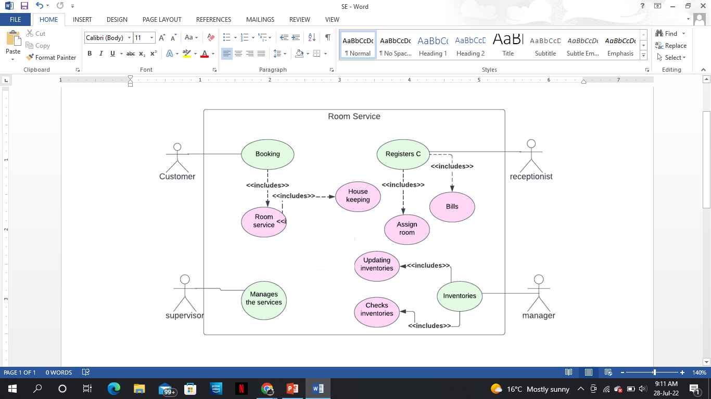

## Class Diagram

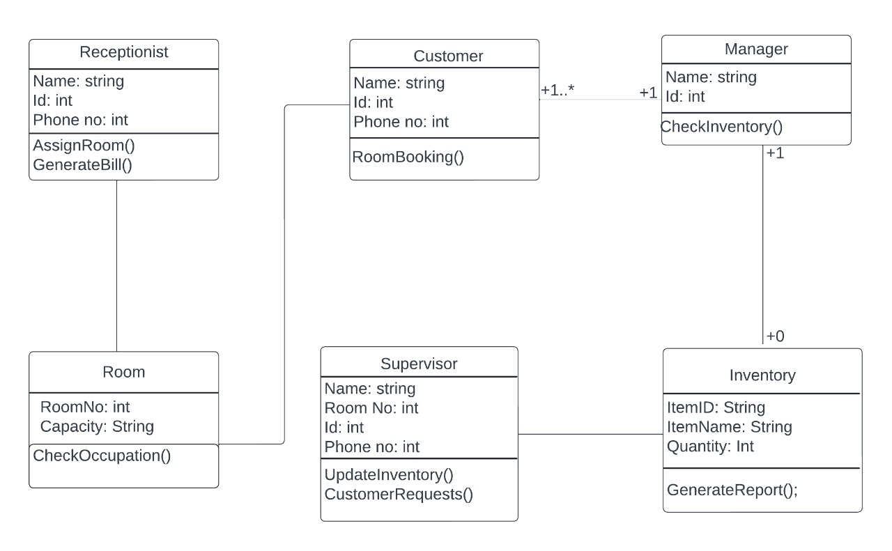

## System Architecture Diagram

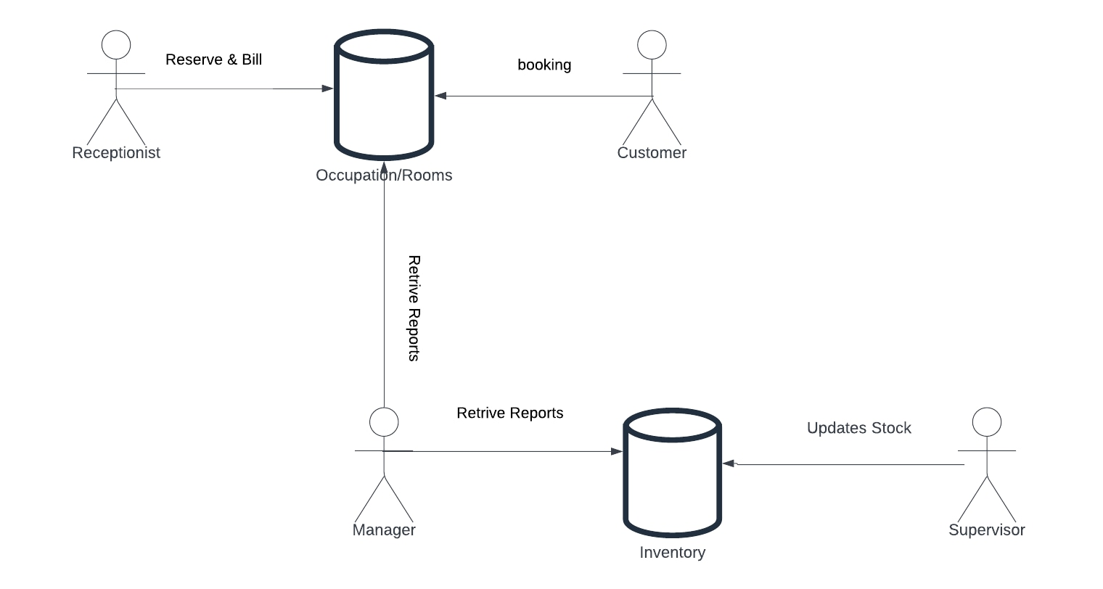

## Sequence Diagram

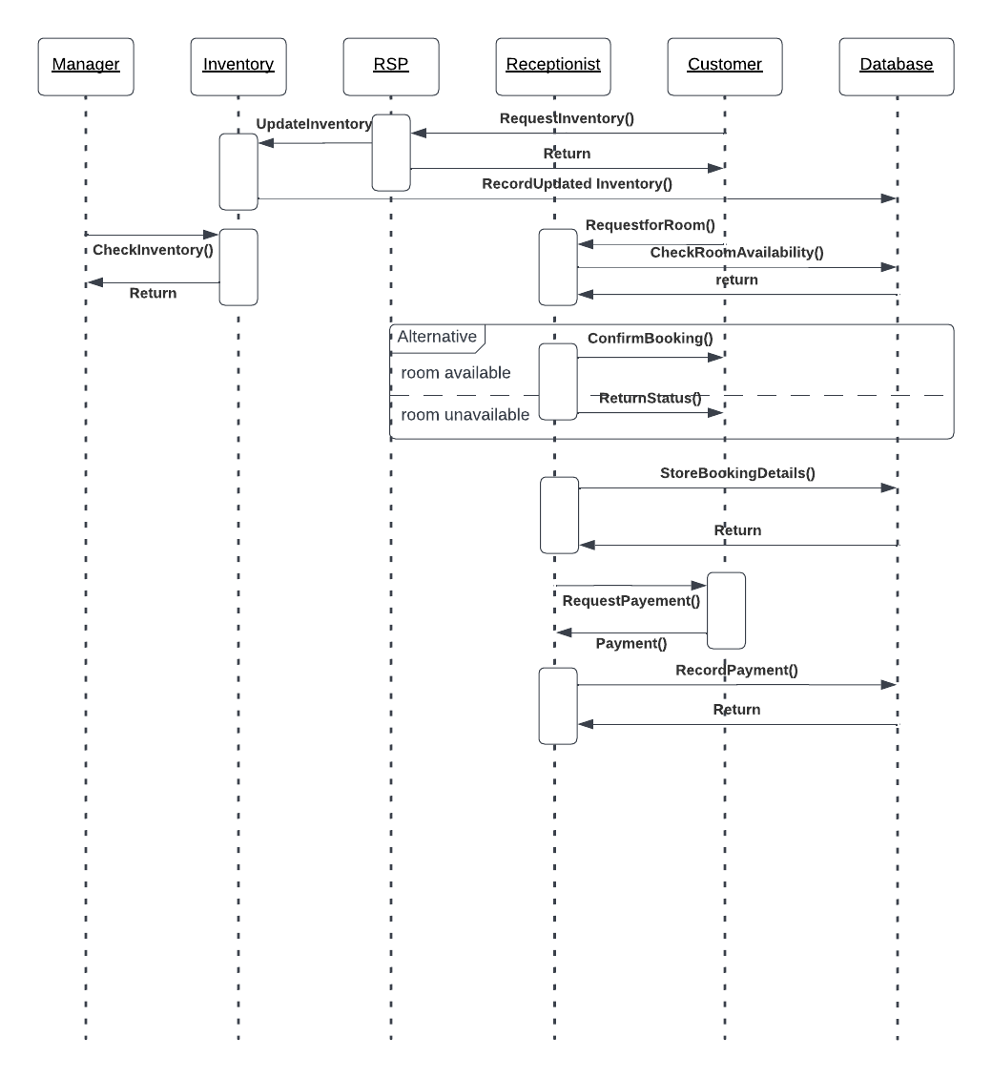

## System Diagrams

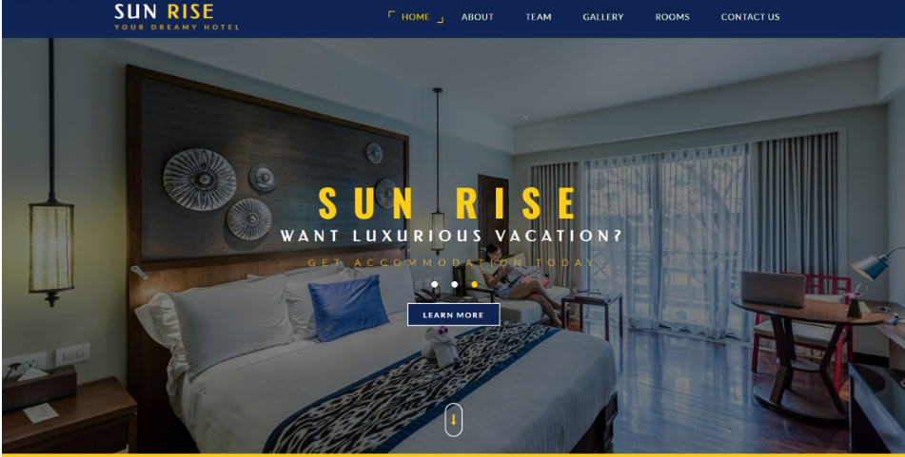

Figure 4. 1:Home page

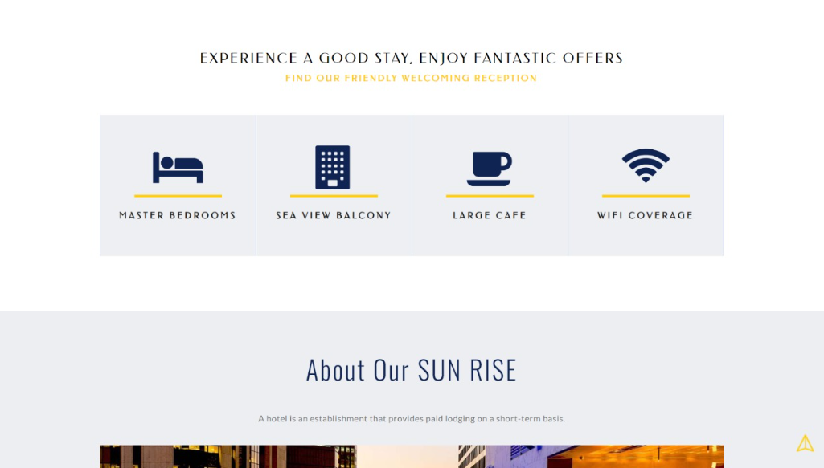

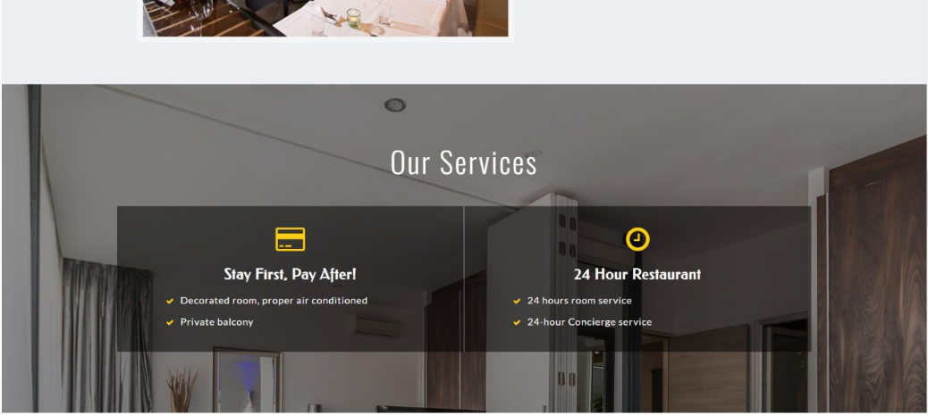

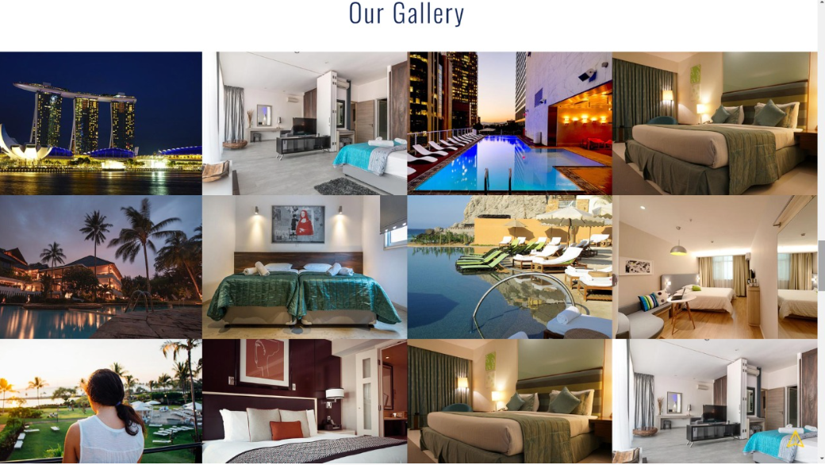

Figure 4. 2:Gallery

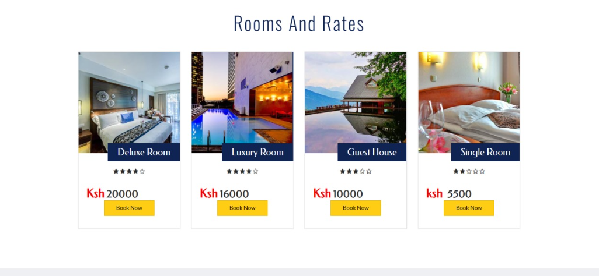

Figure 4. 3:Rooms and Rates

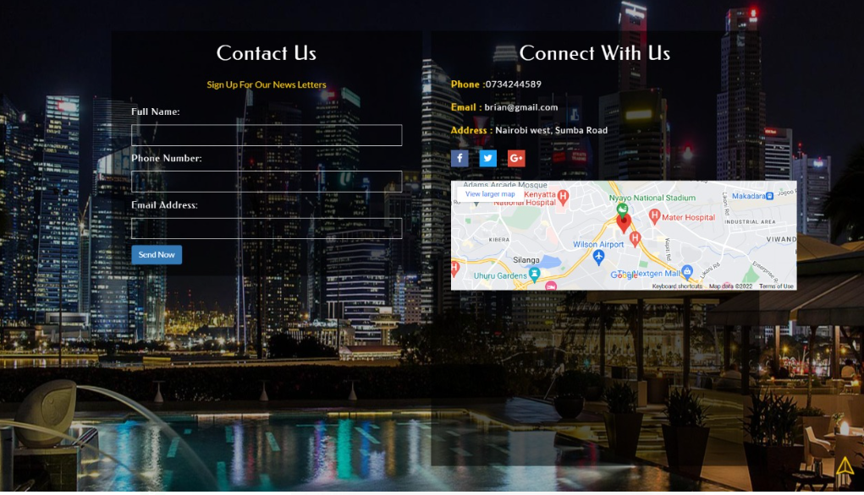

Figure 4.4:Registration

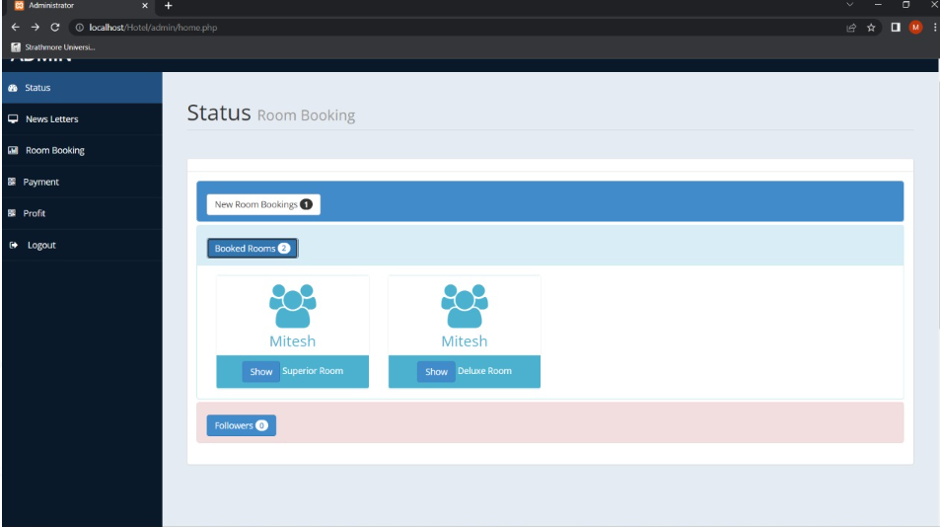

Figure 4.5:Inventory

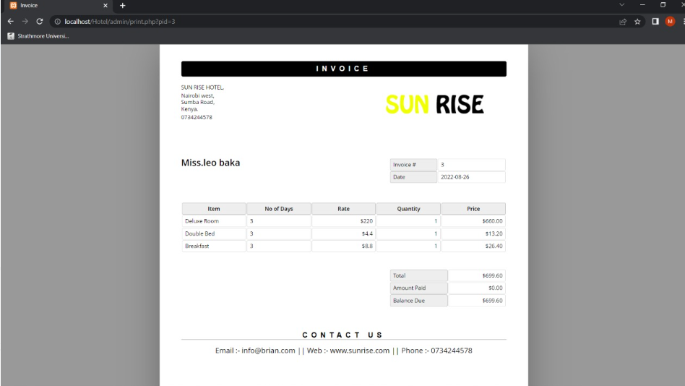

Figure 4.6:Billing

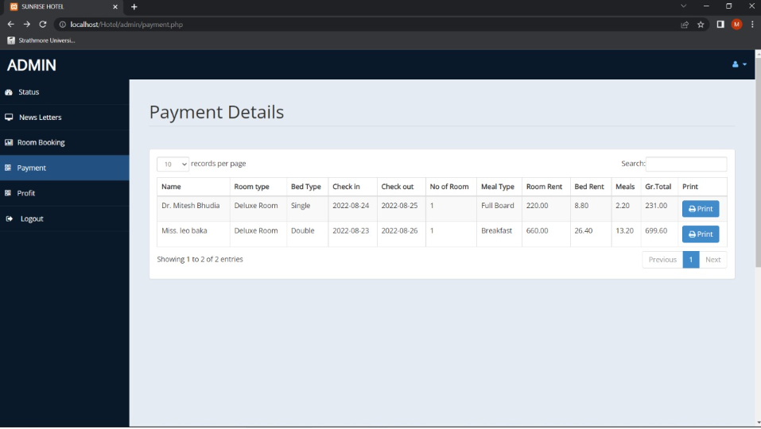

Figure 4.7:Patment details

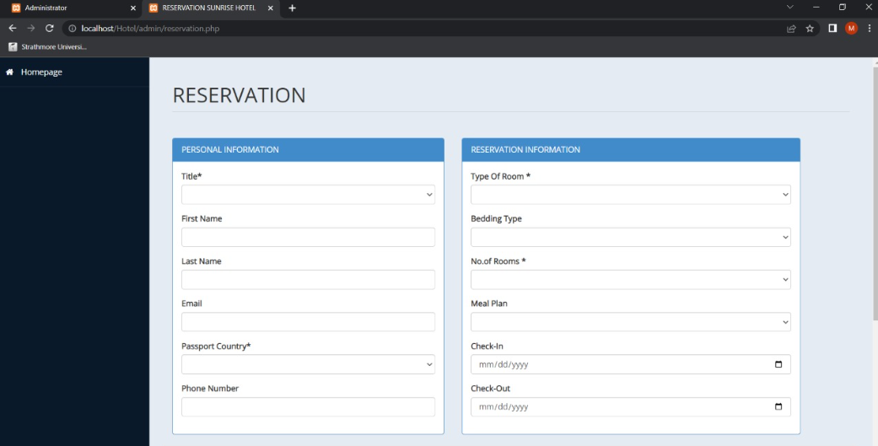

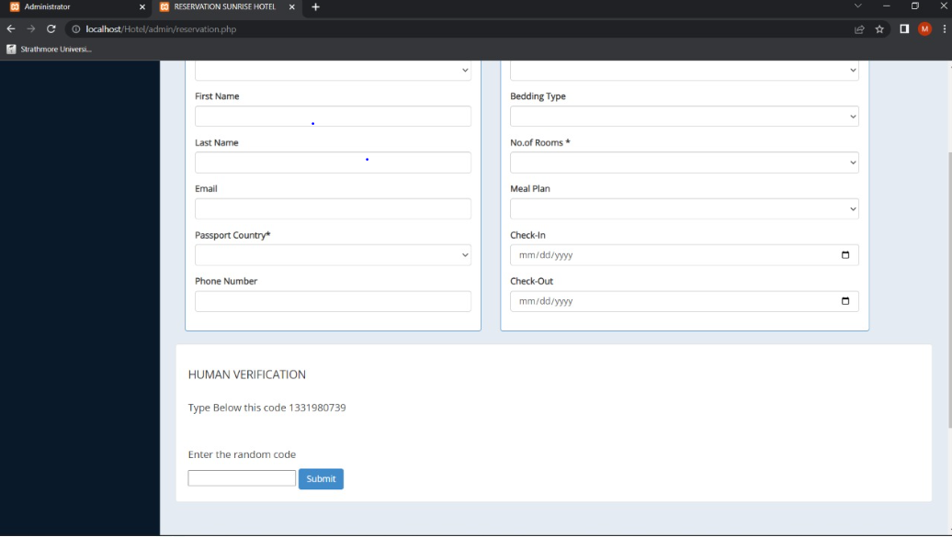

Figure 4.8:Receptionist assigning rooms

# IMPLEMENTATION

System implementation is the most important steps in case of finalizing the approved web system. We need to justify some basic requirement (software & hardware) so that the system will work without having obligation and customers dissatisfactions.

Software Requirement:

♣ Operating System: Windows (XP, 7, 8, 8.1) or Mac OSX (Tiger, Leopard, Snow Leopard, Lion, Yosemite).

♣ Web Browser: Google Chrome, Internet Explorer (ver. 8 or later), Mozilla Firefox, Safari (Mac).

♣ Database Management System: MySQL, SQL Server, Microsoft Access, Oracle.

♣ Others: .NET FRAMEWORK. Hardware Requirement

♣ RAM: Minimum 1GB or higher.

♣ HDD: Minimum 50 GB.

♣ Processor: Intel Pentium 4 or AMD.

♣ LAN: Version 1.6.6.406(For fixing up client disconnection).